# Detecting Financial Fraud with Machine Learning

# 

Furkan Emre Ginyol1, Emirhan Hosanlı2, Melih Çifçi3, Abdul Qadeer Osmani4, Seif Ahmed Elredeini5

1 *Software Engineering Department, Faculty of Engineering and Natural Sciences, Istanbul Atlas University, Istanbul (210504002)*

2 *Software Engineering Department, Faculty of Engineering and Natural Sciences, Istanbul Atlas University, Istanbul (210504040)*

3 *Software Engineering Department, Faculty of Engineering and Natural Sciences, Istanbul Atlas University, Istanbul (210504011)*

4 *Software Engineering Department, Faculty of Engineering and Natural Sciences, Istanbul Atlas University, Istanbul (220504500)*

5 *Software Engineering Department, Faculty of Engineering and Natural Sciences, Istanbul Atlas University, Istanbul (220504545)*

## *Abstract*

*This project aims to develop a machine learning model to detect fraudulent financial transactions. By leveraging supervised learning methods such as Support Vector Machines (SVM) and ensemble techniques like Random Forests, the system will analyze transaction data to identify patterns indicative of fraud. This approach seeks to improve the accuracy and efficiency of fraud detection systems, reduce financial losses for institutions, and enhance consumer trust. The proposed model will be validated using real-world or synthetic financial transaction datasets, ensuring robustness and practical applicability.*

## 1. Introduction Fraudulent financial transactions pose a significant challenge to businesses and individuals, leading to substantial financial losses annually. The evolving nature of fraud schemes highlights the limitations of traditional detection methods, necessitating innovative approaches. This project focuses on leveraging machine learning to detect financial fraud by analyzing transaction patterns and identifying anomalies. The motivation for this project lies in enhancing the accuracy and efficiency of fraud detection systems, which is vital for reducing losses and building consumer trust. Possible solutions include using supervised learning algorithms, such as Support Vector Machines (SVM), and ensemble methods like Random Forests. These techniques offer robust, adaptive, and scalable solutions to the dynamic challenges of fraud detection.

The rest of this proposal is structured as follows: **Related Work** provides an overview of past studies and current methodologies in financial fraud detection; **Project Summary** outlines the main goals, deliverables, and methodology; **Project Details** elaborates on the timeline, architecture, and challenges; and **Conclusion** summarizes the expected contributions and significance of the project.   
 **2. Related Work**  
The field of financial fraud detection has a rich history, evolving from rule-based systems to modern machine learning approaches. Traditional rule-based systems were effective in static environments but lacked the adaptability to address dynamic and evolving fraud patterns. The advent of machine learning introduced models that learn from historical data, allowing systems to detect emerging fraud schemes with improved accuracy and efficiency.

This area is of particular interest due to the escalating complexity and scale of financial fraud, which costs institutions billions of dollars annually. For the technical community, it presents a challenge of balancing model performance, scalability, and real-time applicability. For us, the project offers a valuable opportunity to deepen our understanding of machine learning algorithms and their practical implementation in high-stakes domains.

Several approaches have been proposed to address the problem. Supervised learning algorithms like Support Vector Machines (SVM) have demonstrated their utility in detecting anomalies in transaction data. Ensemble methods, such as Random Forests, have further enhanced robustness by integrating multiple decision trees to handle imbalanced datasets effectively. Studies, such as the work by Zhang et al. (2020), have highlighted how hybrid models combining SVM and Random Forests outperform single-algorithm systems.

Despite these advancements, potential problems merit further investigation:

**Data Imbalance**: Fraudulent transactions are significantly rarer than legitimate ones, making it challenging to train accurate models.

**Generalization to Unseen Data**: Ensuring models perform well on real-world data, including previously unseen fraud patterns, remains difficult.

**Real-time Detection**: Balancing computational efficiency with detection accuracy to enable instantaneous fraud identification.

Although current solutions address many aspects of the problem, improvements are possible in areas such as feature engineering, handling imbalanced datasets, and integrating real-time analytics. By exploring these enhancements, this project aims to advance our skills and contribute to refining existing methodologies.  
 **3. Project Summary**

This project aims to develop a machine learning-based system for detecting fraudulent financial transactions. Fraud detection is critical due to the significant financial losses it incurs for individuals and organizations globally. Traditional systems often rely on static, rule-based approaches that fail to adapt to evolving fraud patterns, leaving institutions vulnerable to novel schemes. By using advanced machine learning techniques, this project seeks to overcome these limitations, offering a dynamic and scalable solution to mitigate financial risks effectively.

The system will leverage publicly available or synthetic datasets of financial transactions, ensuring data privacy while simulating real-world scenarios. These datasets typically include transaction attributes such as amount, location, time, and frequency. Our investigation will focus on supervised learning algorithms, specifically Support Vector Machines (SVM) and Random Forests, known for their robustness and adaptability in handling structured data. Existing implementations of these algorithms in libraries like scikit-learn will serve as the foundation, with modifications to improve their performance on imbalanced datasets—a common challenge in fraud detection.

Evaluation will be conducted using standard performance metrics such as precision, recall, and F1-score, ensuring a comprehensive assessment of the model's effectiveness. Visualizations, including confusion matrices and feature importance plots, will provide qualitative insights into the results. Quantitative analyses will validate the system’s ability to generalize to unseen data and maintain accuracy in real-time scenarios. With a clear plan, access to resources, and a structured timeline, the project is designed to be achievable within the semester while delivering meaningful outcomes.  
  
**4. Project Details**

Deliverables:

- A machine learning model for fraud detection.  
- A detailed project report documenting the methodology, results, and conclusions.  
- Visualizations showcasing model performance and feature importance.

Timeline:

- **Week 1**: Collect and preprocess data, addressing missing values and imbalances. Conduct exploratory data analysis to understand dataset patterns and potential features.  
- **Week 2**: Perform feature engineering to identify relevant transaction attributes. Design initial machine learning models (SVM and Random Forest).  
- **Week 3**: Train and evaluate models using metrics like precision, recall, and F1-score. Iterate on model design based on initial performance.  
- **Week 4**: Refine models, focusing on optimizing for real-time fraud detection. Begin drafting the project report, detailing the methodology and findings.  
- **Week 5**: Deploy the fraud detection system for simulation testing. Create visualizations for model performance and feature importance.  
- **Week 6**: Conduct final evaluation and validation on unseen data. Finalize the project report and prepare for submission. Present results, including insights and recommendations for deployment.

Architecture and Environment:

The system will be developed in Python using libraries like scikit-learn for machine learning, Pandas for data manipulation, and Matplotlib/Seaborn for visualizations. In addition, RapidMiner will be utilized for all stages of model development and testing. The project will use publicly available or synthetic financial datasets, ensuring data privacy while replicating real-world conditions.

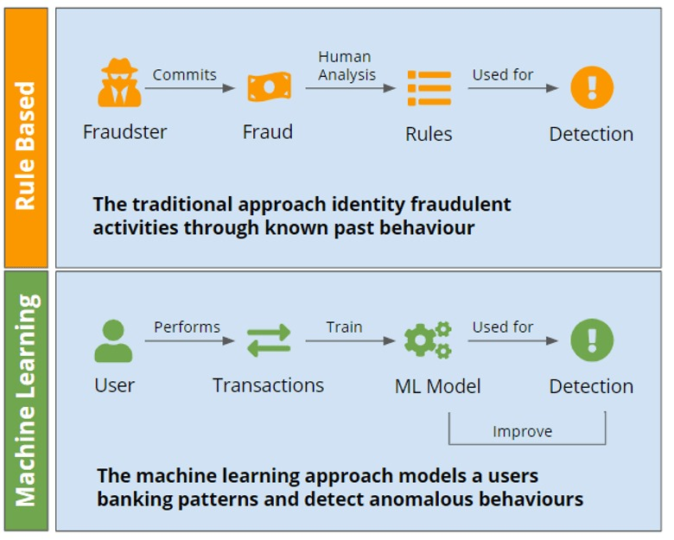

**Figure 1** **-** The diagram above compares rule-based fraud detection with machine learning-based detection.

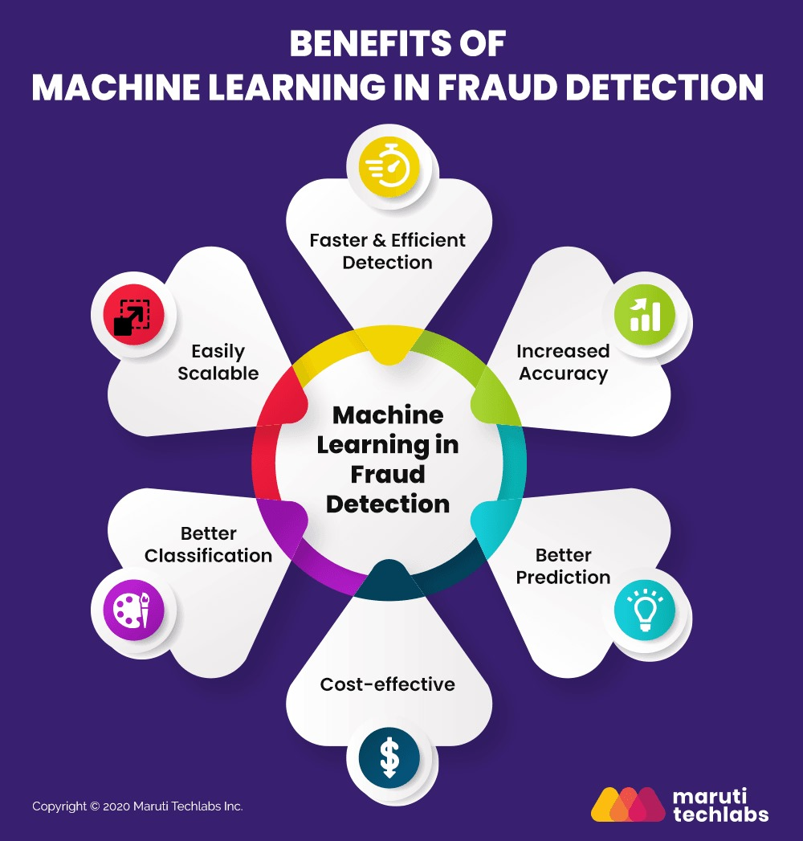

**Figure 2** **–** Benefits of Machine Learning In Fraud Detection

Challenges:

The primary challenges in implementing this fraud detection system are managing data imbalance and ensuring generalization to unseen fraud patterns. Fraudulent transactions are rare, making models prone to bias toward legitimate transactions. Addressing this requires techniques like resampling, synthetic data generation (e.g., SMOTE), and cost-sensitive learning. Additionally, achieving real-time fraud detection poses challenges in balancing computational efficiency and accuracy, especially for low-latency processing.

The project extends existing tools, including Python libraries like scikit-learn and RapidMiner, while integrating enhancements like optimized pipelines and hybrid models. Its uniqueness lies in adapting machine learning to evolving fraud patterns, emphasizing scalability, and leveraging ensemble techniques for robust, dynamic detection compared to static, rule-based systems.  
  
  
**5. Conclusion**   
  
This project aims to leverage machine learning techniques to build an effective financial fraud detection system. By utilizing SVM and ensemble methods, the proposed solution will address existing challenges in fraud prevention. Successful implementation will demonstrate the practical value of machine learning in combating financial fraud, benefiting both institutions and individuals.  
  
**6. References**   
  
[1] Y. Zhang and X. Li, "Random Forests for Imbalanced Fraud Detection," IEEE Transactions on Data Science, 2020.  
  
[2] L. Breiman, "Random Forests," Machine Learning, vol. 45, no. 1, pp. 5-32, 2001.  
  
[3] C. Cortes and V. Vapnik, "Support-vector networks," Machine Learning, vol. 20, no. 3, pp. 273-297, 1995.  
  
[4] P. Sidelov, "Fraud Prevention," SDK Finance, Jun. 30, 2021.  
https://sdk.finance/all-you-need-to-know-about-machine-learning-based-fraud-detection-systems/  
  
[5] Maruti Techlabs, "Machine Learning Fraud Detection,"  
https://marutitech.com/machine-learning-fraud-detection/